**CHAPTER 3**

**SYSTEM DESIGN**

Systems design is the process of defining the architecture, modules, interfaces, and data for a system to satisfy specified requirements. Systems design could be seen as the application of systems theory to product development.

**3.1 Basic information**

Online Room Booking Sytem(ORBS) is developed to book room in an easy and quick manner to the users. ORBS delivers via the users interface as online system which is acting as a service provider. By using the technology rooms can be booked efficiently on time than visiting a hotel. The system contains two modules which are admin and users. The users can get registered and login to book rooms. The admins can thereby view the room booking details. Admin has privilege to manage users details also can keep track on room booking activities.

**3.2 ER diagram**

An entity relationship model, also called an Entity-Relationship (ER) diagram, is a graphical representation of entities and their relationships to each other, typically used in computing in regard to the organization of data within databases or information systems.

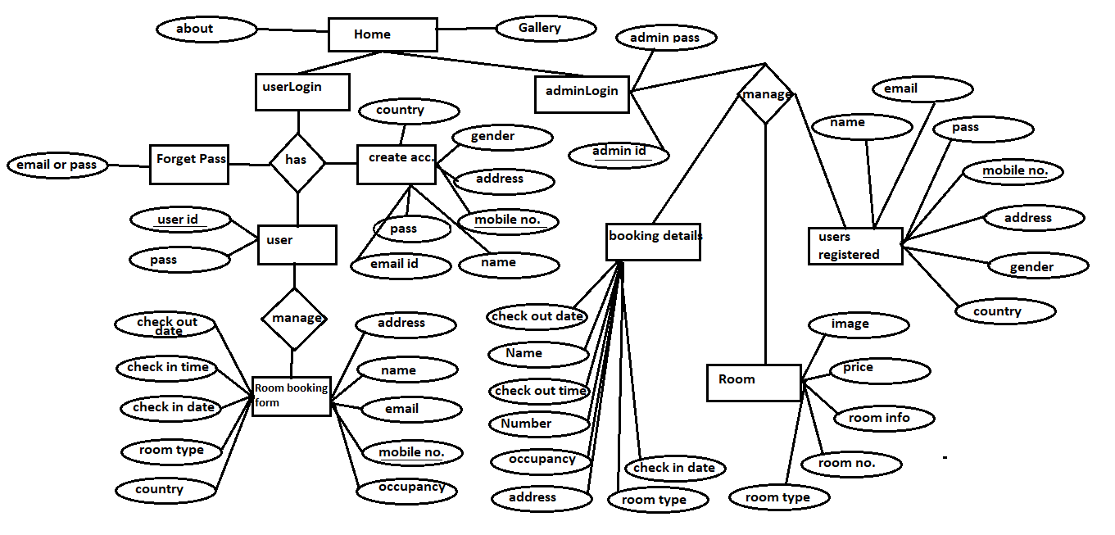

***Fig 3.1:*** *ER diagram for Online Room Booking Sytem.*

**3.3 Use Case diagram**

UML Use Case Diagrams. Use case diagrams are usually referred to as behavior diagrams used to describe a set of actions (use cases) that some system or systems (subject) should or can perform in collaboration with one or more external users of the system (actors).

User Admin

Online Room Booking System

Login

Register

Room Booking

Booking Status

Reject/Cancel

***Fig 3.2:*** *Use Case diagram for Online Room Booking System.*

**3.4 Data Flow diagram**

A data flow diagram (DFD) is a graphical representation of the "flow" of data through an information system, modelling its process aspects. A DFD is often used as a preliminary step to create an overview of the system without going into great detail, which can later be elaborated.

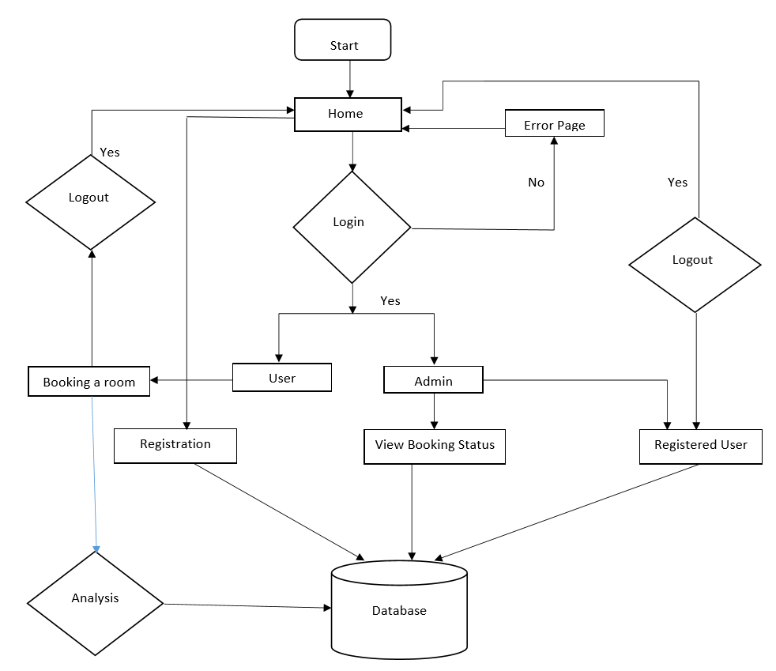

***Fig 3.3:*** *Data Flow diagram for Online Room Booking System*